1. Find XPath for find list of all required fields on the page. How many have you found?

//input [@required] Five elements matching

2. Write unique xpath for label “Country of Origin”

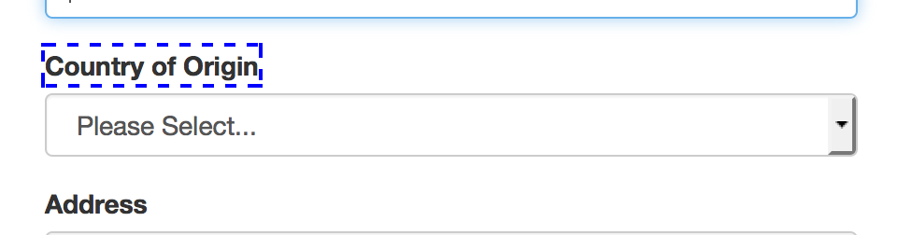

//label[contains(text(),'Country of Origin')]

3. Find xpath for field “Confirm Password” using 2 attributes: first attribute – your choice, second is “disabled”, re-verify xpath when field is not disabled (after you put value in password field)

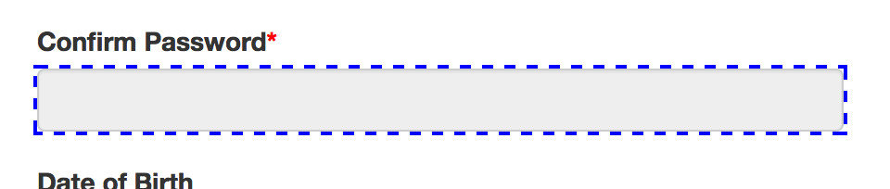

//input[@id='confirmPassword'] [@disabled]

4. Find unique xpath for option “Toyota” in select list “Car Make”

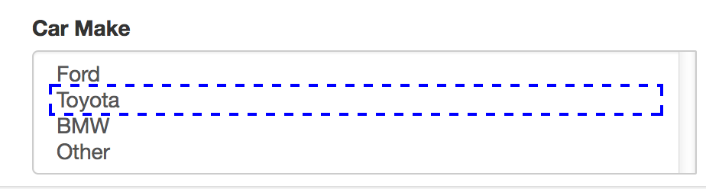

//option[contains(text(),'Toyota')]

//select[@name='carMake']/option[contains(text(),'Toyota')]

5. Find unique xpath for option “Canada” in select list “Country of Origin”

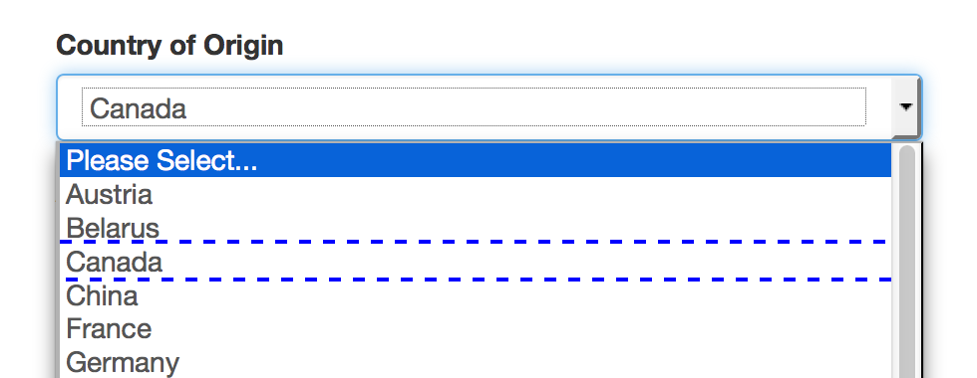

//select [@name='countryOfOrigin']/option[contains(text(),'Canada')]

//select [@name='countryOfOrigin']/option[text()='Canada']

6. Find unique xpath for radio button Female by 2 attributes

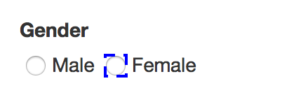

//\*[@name='gender'][@value='female']

//input[@name='gender'][@value='female']

7. Find unique xpath for label “Phone Number” and then go down to the input field using xpath you wrote for label as an anchor

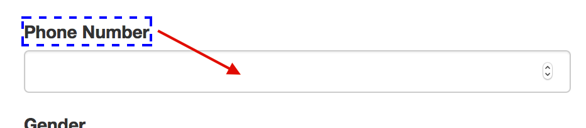

//label [@for ='phone']/../input

8. Find unique xpath for Application Date value and label

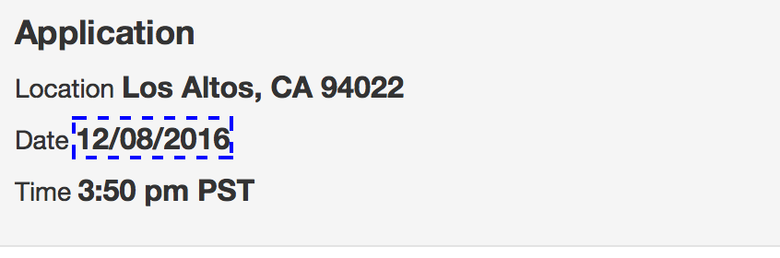

//b[@id='currentDate']/..

9. Click input Name and find xpaths for First, then for Last, then for Middle names and after - for Save, Cancel Buttons

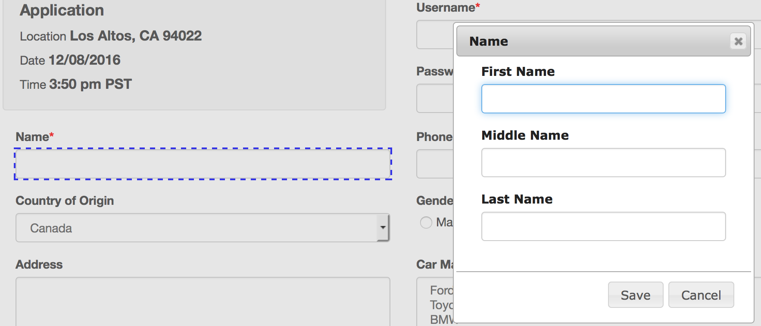

//input[@id='firstName']

//input[@id='middleName']

//input[@id='middleName']

//span[contains(text(),'Save')]

//span[contains(text(),'Cancel')]

10. Find unique xpath for Privacy Policy acceptance by text

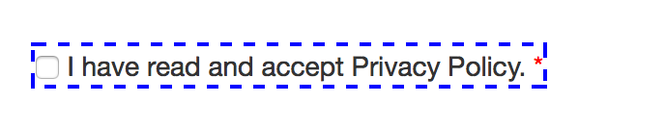

//span[contains(text(),'I have read and accept Privacy Policy.')]

11. Find unique xpath for “Related documents” button by partial text

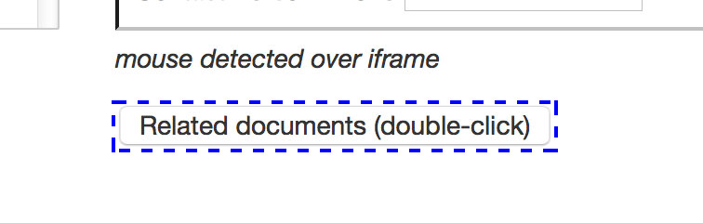

//button[contains(text(),'Related (click)')]

12. Type 2 characters to field “Password”, find unique xpath by text “Please enter at least 5 characters.”

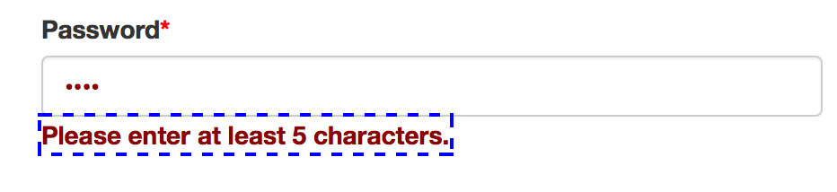

//label[@id='password-error']